India Corruption Survey 2018
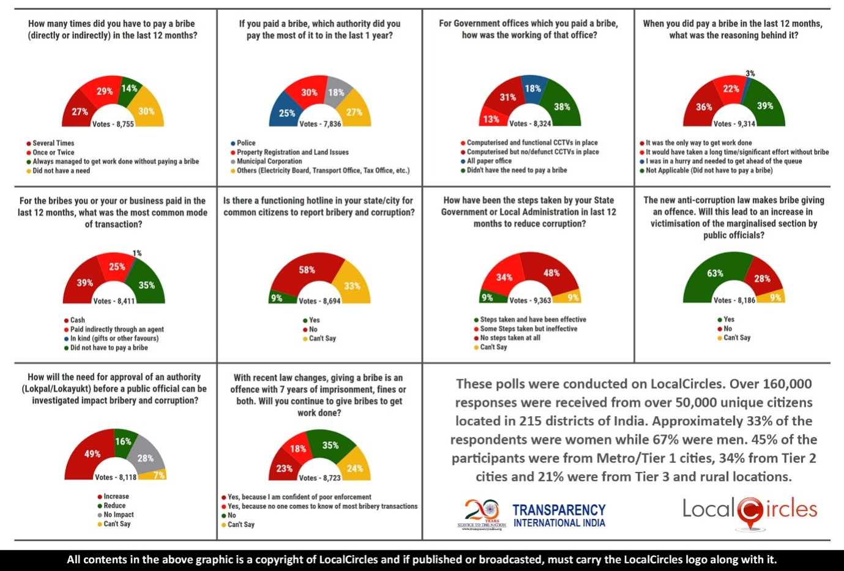
India Corruption Survey 2018: 56% citizens say they paid a bribe in the last 1 year (Only 45% said so in the year 2017)

October 2018, New Delhi
LocalCircles in collaboration with Transparency International India has recently conducted an Online National Survey to ascertain the level of corruption in the country and check the citizen pulse on it. The data collected from the survey has been compiled in a comprehensive report called the ‘India Corruption Survey 2018’.
The survey has been conducted at an opportune time as the new Prevention of Corruption (Amendment) Act, 2018 has been passed by the Indian Parliament and it is set to transform the anti-corruption regime in the country.
Countless studies around the world show how corruption can interrupt investment, restrict trade, reduce economic growth and distort the facts and figures associated with government expenditure. But the most alarming form of corruption is one affect daily lives of common citizens, studies confirm direct correlation of level of corruption with increasing levels of poverty and income inequality. Transparency International India and LocalCircles through this survey have tried to gather opinions of the citizens of India on the recent happening like status of day to day corruption encountered by common man and also perception of people about recent changes in the anti-corruption law
Daily lives of common citizens and the problems they face when it comes to accessing basic services have been the focus of this survey. It does not deal with any aspects of grand corruption as such. However, our results show that common citizens are becoming more and more aware of corruption related issues which is definitely a positive sign. As without being aware of their basic rights and the forms in which corruption is spreading in our country, nothing concrete can be done to save the country from this cancerous problem
45% citizens of the country had paid bribes, according to the last year’s survey. But this year’s survey reveals a definite and noticeable increase in the number of times bribes are paid by the citizens either directly or indirectly. The increased percentage of citizens is 54%.
According to the survey, 58% of the citizens said their states had no anti-corruption helpline. Whereas as many as 33% said they were not aware of the presence of such helpline in their states. This shows the lack of will from the states to ensure that citizens become aware of corruption issues and get involved in the fight against corruption by reporting cases and instances of bribery and corruption.
It seems cash is still the primary mode of bribery because around 39% paid cash as bribery, followed by bribes through agents (25%), bribes in kind (1%). Police authorities have been paid the most bribes by the citizens in the last year (25%), followed by municipal corporations, property registrations and other authorities (electricity board, transport office, tax office etc.).
An interesting thing to note is that despite computerisation of government offices, cases of bribery have continued. Although installation of CCTVs cameras has been a deterrent for the offenders, as only 13% of the surveyed citizens paid a bribe to government offices which had CCTVs installed.
This survey also revealed that bribe giving has become so rampant in the country just for the purpose of getting the work done conveniently without wastage of time and effort. Lack of will and initiative on the part of the states is also brought to the forefront as only 34% of the citizens said that states have taken steps to curb corruption but these have not been effective.
Transparency International India and LocalCircles through this survey have also tried to gather opinions of the citizens of India on the recent changes in the anti-corruption law. Since, the law has made bribe giving an offence with 7 years of imprisonment or fine or both; it was shocking to see that 23% agreed that they will continue giving bribes to get work done because they doubt the enforcement of the act. This means the citizens have a feeling that the new anti-corruption law will not have much effect.
Around 63% also feel that the new amended law will increase the victimization of people by the public officials because they feel that the law will become a tool in the hands of the officials to harass even those who are honest.
Along with that, as many as 49% of the citizens said the need for a prior approval of an authority before a public official can be investigated, will lead to increase in bribery and corruption as it will make it all the more difficult to prosecute the corrupt officials quickly.
We hope this survey and many more such periodic, educative and purposive surveys are able to empower citizens and enable the government in the fight against corruption and make sure that such a malaise is combated in an effective manner.

For more details contact:
Shri Akshay Gupta- Shri Brij Bhushan Singh-
Email id: media@localcircles.com Email Id: brijbhushan@transparencyindia.org
Phone No: +91-8585909866 Phone No: 7827742035/9415392920

